Creating tables

Objectives
At the end of this session, the student will be able to:
- Work with table in an SQL Server database
- Add and drop columns in a table
- Add and drop constraints in a table

Part I – 90 Minutes
Exercise 1 : Creating tables
- St. Paul’s Training Institute is a training institute located in Los Angeles, USA. The institute provides training in various courses in different fields such as science, mathematics, and so on. Recently, the institute started using a primitive database system in which it stores the student and staff details. In the current database, there is only one table to store the student details and another to store the staff details.

However, the users are finding it very difficult to trace student and staff records since, all the details are in the same table.
(Assumption: Database is already created.)

You as a database developer have to accomplish the following tasks:
- Create separate tables to store student details, marks details, employee details, salary details, and course details.
- Create required columns in each table to store the relevant details.
- Use appropriate data types for the columns to store the different type of data such as name, phone, email, salary, fees, and so on as per requirement.
- Apply appropriate check constraints on the type of data to be stored in the respective columns.
- Set the primary and foreign key constraints on appropriate columns to relate the relevant tables.
- Insert new records in each table and verify that all the check constraints are working properly.
- Update and delete records in the table to ensure primary and foreign key constraints are working properly.
- Identify columns that may hold null value and apply constraints accordingly.
The tables have the following structures respectively :

Field name | Data type | Constraint | Describe
Rollno | Char(10) | Primary key | Student code
StuName | Varchar(30) | Not null | Student name
Gender | Varchar(10) | Not null, only accept ‘male’ or ‘female’ value | Gender of student
Address | Varchar(100) |  | Student address

Table 3.1: STUDENT TABLE

Field name | Data type | Constraint | Describe
SubID | Char(10) | Primary key | Subject Code
SubName | Varchar(50) | NOT NULL | Subject name
Theory | Int | Only accept positive value | Theory period
Lab | Int | Only accept positive value | Lab period
Table 3.2: SUBJECT TABLE

Field name | Data type | Constraint | Describe
Rollno | Char(10) | Foreign key of STUDENT table | Student code
SubID | Char(10) | Foreign key of SUBJECT table | Subject code
Examtimes | Int | only accept 1 or 2 value | Exam times of student
Marks | Int | Only accept value from 0 to 100 | Exam mark

(Rollno, SubID, Examtimes) is a primary of EXAMMARK table
Table 3.3: EXAMMARK TABLE

Field name | Data type | Constraint | Describe
DeptNo | Char(3) | Primary key | Department number or ID.
DeptName | varchar(36) | Not null | A name describing the general activities of the department
MgrNo | Smallint | Not null | Employee number (EMPNO) of the department manager.
AdmrDept | char (3) | Not null, Foreign key of DEPARTMENT table | The department (DEPTNO) to which this department reports; the department at the highest level reports to itself.
Location | char (16) |  | Location of the department.

Table 3.4: DEPARTMENT TABLE

Field name | Data type | Constraint | Describe
ID | Smallint | Primary key | Employee number
Name | Varchar(9) | Not null | Employee name
Dept | Char(3) | Not null, Foreign key of DEPARTMENT table | Department number or ID.
Job | Char(10) |  | Job title
Years | Smallint |  | Years with the company
Salary | Numeric(18,0) | Default 100 | Employee's annual salary
Comm | Numeric(7,2) |  | Employee's commission

Table 3.5: STAFF TABLE
Exercise 2 : Insert, update and delete records in the tables to ensure the constraints are working properly base on the following data

DEPTNO | DEPTNAME | MGRNO | ADMRDEPT | LOCATION
A00 | SPIFFY COMPUTER SERVICE DIV. | 1 | A00
B01 | PLANNING | 3 | A00
C01 | SALE | 2 | B01
D01 | DEVELOPMENT CENTER | 10 | B01
D11 | MANUFACTURING SYSTEMS | 8 | B01
D21 | ADMINISTRATION SYSTEMS | 9 | D01
Table 3.6: DEPARTMENT

ID | NAME | DEPT | JOB | YEARS | SALARY | COMM
1 | Sanders | A00 | Mgr | 10 | 11000
2 | Pernal | C01 | Mgr | 7 | 6000 | 200
3 | Smith | B01 | Mgr | 8 | 8000
4 | O'Brien | C01 | Sales | 5 | 5000 | 150
5 | Hanes | C01 | Sales | 6 | 5000 | 150
6 | Rothman | C01 | Sales | 2 | 4000 | 120
7 | James | C01 | Sales | 3 | 4500 | 135
8 | Koonitz | C01 | Analyst | 3 | 4500 | 135
9 | Plotz | C01 | Operator | 2 | 4200 | 100
10 | Ngan | D01 | Clerk | 1 | 3500
Table 3.7: STAFF
Part II – 30 Minutes
Exercise 3 : Create SELL_MANAGE database with the following tables :
- Add PHONENO column to STAFF table with datatype char(15)
- Add constraint to PHONENO column to ensure the value alway begin with ‘0’
- Insert new row to STAFF table with the following data :
11 | Mary | D01 | Mgr | 1 | 4500 |  | ‘123456’
- Drop PHONENO column of STAFF table.
- Every employee can only manager one department. Add constraint to ensure the MGRNO column of Deparment table can not contain duplicate values.
- Update MGRNO column of deparment ‘D01’ to 9

Part III – Do it yourself
Exercise 4 : Create SELL_MANAGE database with the following tables :

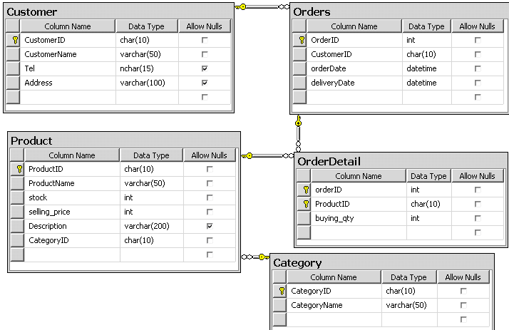

Exercise 5 : Write SQL statements to solve the following questions :
- Add new data to SELL_MANAGER table to check if they are working properly.
- Modify the table Orders to add a default value of current day for OrderDate.
- Add constraint to table Orders to ensure deliveryDate greater than or equal orderDate.
- Add new column Price to OrderDetail table with int datatype.
- Update the Price of OrderDetail equal to the price of corresponding products.

Exercise 6 : Write SQL statement to insert following data into table in part I

Rollno | St_name | Gender | Address
SV01 | Tran Ngu Binh | Female | So 2 Hai Ba Trung, TPCT
SV02 | Ton That Nghiep | male | Long Xuyen, An Giang
SV03 | Ly Cong Bang | male | Cai Be, Tien Giang
SV04 | Nguyen Ngoc My Le | Female | 20/5 Tran Hung Dao, TPCT
Table 3.8: STUDENT TABLE

SubID | SubName | Theory | Lab
EPC | Logic Building with C | 30 | 30
HDJ | HTML, DHTML, JavaScript | 25 | 30
DWMX | Dreamweaver MX | 20 | 22
SQL | SQL Server 2005 | 20 | 30
Table 3.9: SUBJECT TABLE

Rollno | SubID | Examtimes | Marks
SV01 | EPC | 1 | 40
SV01 | HDJ | 1 | 50
SV02 | HDJ | 1 | 20
SV02 | HDJ | 2 | 70
SV03 | EPC | 1 | 30
SV03 | EPC | 2 | 90
SV04 | SQL | 1 | 80
Table 3.10: EXAMMARK TABLE

